

The Olympic .38 blank firing revolver ban
Click here for full press release - ACPO Firearms Amnesty press release

The police have highlighted that the Olympic BBM .380 calibre blank firing revolver (all variants) is now a prohibited weapon due to recent forensic tests and their prevalence in crime. The Association of Chief Police Officers (ACPO) organised an amnesty which ran until 4th June 2010. The object was to allow as many of these imitations to be handed in as possible without fear of prosecution, regardless of whether they have been converted by criminals or remain unconverted for legitimate use.

The amnesty now being over means that these items are still prohibited but there is a risk of prosecution for possession, however Home Office guidance recommends to police that there should be an emphasis on creating an environment in which people hand in illegally held firearms. It is perfectly understandable that the information about the ban will not have filtered to everybody during the amnesty and as people become aware, they will be keen to hand the guns into police in a responsible manner.

The decision to ban this firearm coupled with an amnesty was initiated by ACPO with full support from BASC, The Gun Trade Association (GTA) and the British Shooting Sports Council (BSSC) and it is evidence led. These imitations have not just been used as a means to intimidate others they have been used in crime in a converted state. We have to act to protect public safety.

Does this ban cover all blank firing imitations?
Naturally BASC members may be concerned that other imitations might be caught by this amnesty; however this amnesty has been based on scientific analysis of the .380 calibre Olympic BBM imitation revolver and their prevalence in crime.

Will other types of blank firing imitation be banned in the future?
There are no current plans to deal with other types of blank firing imitations in this manner, but this does not mean that other blank firing imitations currently held by people remain legal. Any imitation firearm capable of being readily converted, as defined by the 1982 Firearms Act, is illegal whether it has actually been converted or not. Imitations have been sold over many years in various different specifications and each case has to be looked at on its merits.

What about the Olympic 6 .22 calibre revolver?
This amnesty is complicated by the fact that the .380 calibre Olympic BBM revolver has a cousin in the format of the ‘Olympic 6’ .22 calibre revolver, which is very similar in looks to the .380 calibre version and is used by the vast majority of dog trainers in the UK. The .22 BBM revolver variant is not subject to the Amnesty. To tell the difference the .380 calibre blank is a centre fire cartridge and the revolver holds 5 shots. The .22 is rim-fire ignition and holds 6 shots.

What does the Olympic .380 revolver look like?
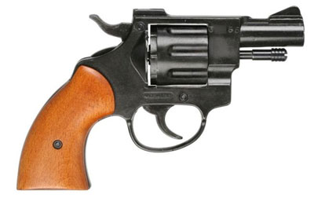
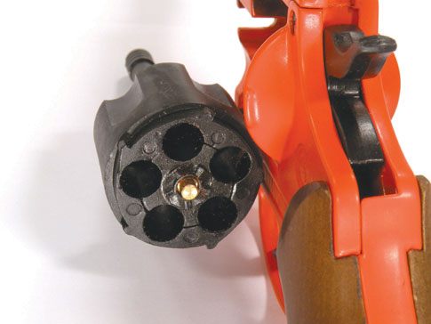

Please note that these photographs are for illustrative purposes only. Since the Violent Crime Reduction Act 2006, these guns are sold in Orange and possibly other colours prescribed by VCR Act regulations.
The Amnesty applies to all variants regardless of colouring.

Website Resources

NaBIS - http://www.nabis.police.uk/ ACPO CUF - http://www.nabis.police.uk/acpo-intro.asp

